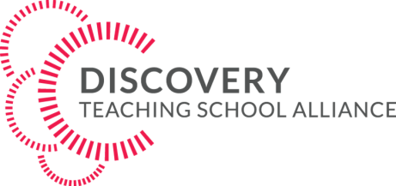
VENUE: St PETER’S SCHOOL,
St PETER’S ROAD,
HUNTINGDON.
PE29 7DD
YOUR DETAILS

 |  | FIRST DELEGATE |  | SECOND DELEGATE
Title:
First name:
Last name:
Your email:
Best contact telephone number:
Job Title:
School/Organisation name:
School/Organisation address:
Finance dept –Send invoice to:
Finance dept email address:
TRAINING SESSIONS
Please indicate in the boxes below each session you wish to attend
INTRODUCTION TO MENTAL HEALTH  6TH MARCH 2018  2PM – 4PM  COST £30.00 | ANXIETY AND DEPRESSION  24TH APRIL 2018  2PM – 4PM  COST £30.00 |  | SELF HARM  15TH MAY 2018  2PM – 4PM  COST £30.00 |  | BUILDING RESILIENCE  12TH JUNE 2018  2PM – 4PM  COST £30.00
YES/NO | YES/NO |  | YES/NO |  | YES/NO
TOTAL COST FOR INVOICING:
Discovery TSA are bringing you YMCA Trinity Group to deliver you four different courses in Mental Health Staff Training. Please complete the booking form below and email the form to: discoverytsa@springcommon.cambs.sch.uk to reserve your place.
Parking is available in the adjacent area between the school and leisure centre.
PLEASE EMAIL THIS COMPLETED FORM TO: discoverytsa@springcommon.cambs.sch.uk Your place is only confirmed once payment has been made.

